Tata Motors launches Xenon Pick-up in Nepal

Kathmandu, September 10, 2013: Tata Motors today launched the Tata Xenon Pick-up in the Nepalese market, with best-in-class looks, operating economics and fuel efficiency. The Tata Xenon Pick-up is suitable for a wide range of commercial applications, and will be available in both single cab & dual cab versions.

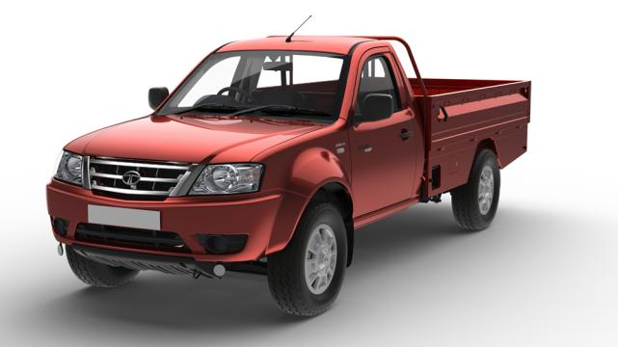
A perfect blend of looks and performance, the Tata Xenon Pick-up has an imposing stance. Distinct flared wheel arches, European styling, chrome-plated grille and sporty body colored bumpers, lends to the Tata Xenon aggressive looks. The neatly laid out interiors provide for optimal space and functionality, along with a pleasant feel, even when negotiating the toughest terrains. The vehicles 3.0 Litre Turbo Direct-Injection engine, delivers a top speed of 120 kmph with best-in-class fuel efficiency. The powerful gear box of the Xenon is designed keeping mind ruggedness and ease of use.

Mr. R T Wasan, Head (International Business – Commercial Vehicles), Tata Motors, said, “We are proud to announce the launch of the Tata Xenon Pick-up, a product with best-in-class styling, performance, value, superior quality, comfort and safety. With the Tata Xenon, the vehicle will cater to customers aspiring to have a stylish pick-up, boasting best-in-class power, yet providing the overall performance of an efficient work-horse.”

Mr. Shambhu Prasad Dahal, Sipradi Trading Pvt. Ltd. said, “Tata vehicles are known to offer high value proposition to the Nepalese customer, for their utility, ruggedness and fuel-efficiency. With the new Tata Xenon Pick-up, it is our endeavour to offer best value to our customers and hope to further consolidate our position in the growing Nepalese Pick-up market, attracting newer buyers, with the best vehicle experience. As Tata Motors expands its position in the Nepalese market, we at Sipradi will continue to support these products with the best purchase and high quality after sales service experience”.

The Tata Xenon is versatile, with payload options to suit varied business requirements, with the longest-in-class body length of 8'4". Features like convenient loading height, 3-side drop load body bring ease to day-to-day operations. The vehicle also comes with 2-stage semi elliptical leaf in the rear suspension, designed to give good road grip, balance, secure turning on bends, good high speed control even when heavily loaded, making the new Tata Xenon suited for all applications on all road conditions.

The vehicle is matched with commensurate power and comes with 3.0 Litre Turbo Direct-Injection engine, which delivers a top speed of 120 kmph with peak power of 72HP and a peak torque of 223nm, with best-in-class fuel efficiency. With its flat torque characteristics, the overdrive gearbox, radial tyres and an aerodynamic shape, contributes to its high fuel efficiency. With a gradeability of 32%, the vehicle will also prove highly reliable in hilly terrains of Nepal.
The Tata Xenon also comes equipped with power steering, adjustable steering column, and cushioned bucket seats in the front with adjustable lumbar support. There are conveniently placed utility spaces, clutch foot rest and a mobile charging point.

Designed to meet global safety standards the Tata Xenon offer safety features like the unique 3-layered body construction, crumple zones, a collapsible steering column, central locking, retractable seatbelts and side intrusion beams which will protect passengers in the event of a side impact collision.

The Tata Xenon Pick-up will be available at all Tata Motors – Sipradi dealerships across Nepal and will be offered with a warranty a 3 lakh kms or 3 years, whichever is earlier.

The new Tata Xenon Pick-up will join Tata Motors existing pick-up portfolio which comprises of the Tata 207 DI Pick-up in the Large Pick-up segment and the Tata Super Ace, in the Small Pick-up segment.

More information on the product is available on www.cvglobal.tatamotors.com

About Sipradi Trading Pvt. Ltd.
Sipradi a major player in Automotive & Allied business and is one of the largest and most prestigious brands in Nepal. 30 years down the line, Sipradi has exceeded USD 150 million in annual revenues and is growing rapidly in automotive, energy, lubricant, financial services, equipment businesses & continue to be a dominating player with over 40% Market share in the CV industry. It has more than 600 employees working to a common goal --to deliver quality products and services while adding synergy to the growth of overall brand value. Sipradi Trading Private Ltd (STPL) has been the exclusive distributor of Tata Motors Ltd in Nepal since 1982. STPL is an ISO 9001:2008 certified company. STPL sells and services the full range of Tata Motors' commercial and passenger vehicles. The company has the largest sales and service distribution network throughout.

About Tata Motors
Tata Motors is India's largest automobile company, with consolidated revenues of Rs. 1,88,818 crores ($ 34.7 billion) in 2012-13. Through subsidiaries and associate companies, Tata Motors has operations in the UK, South Korea, Thailand, Spain, South Africa and Indonesia. Among them is Jaguar Land Rover, the business comprising the two iconic British brands. It also has an industrial joint venture with Fiat in India. With over 8 million Tata vehicles plying in India, Tata Motors is the country’s market leader in commercial vehicles and among the top in passenger vehicles. It is also the world's fifth largest truck manufacturer and fourth largest bus manufacturer. Tata cars, buses and trucks are being marketed in several countries in Europe, Africa, the Middle East, South Asia, South East Asia, South America, CIS and Russia.

(www.tatamotors.com ; also follow us on Twitter: https://twitter.com/TataMotors)

For Further Details:
Ms. Minari Shah
Head of Corporate Communications
Tata Motors Ltd.
Email: minari@tatamotors.com
Telephone No: 022 66657289

